Assessment 3: Short Answer Questions
Student Name

Instructions
This assessment consists of twenty (20) short answer questions. Answer the questions as you work through the Learner Manual and participate in the Q&A’s.
You must answer all the questions. A guide to the length of your answer is provided next to each question.
Please note where a question refers specifically to NSW law or a NSW organisation please provide an answer based on the law/organisation in your own state or territory.

1. Your supervisor has asked you to locate the contact details for the nearest Aboriginal Legal Service. Your initial search returns the following information (see screenshot below).
How might you refine your search to increase the relevance of information or content found? Ensure you provide one (1) specific example of how you might alter the search. (40-60 words)

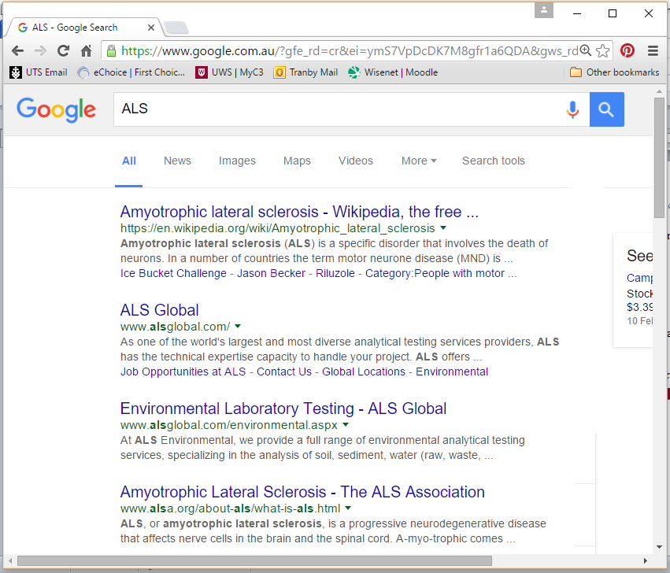

2. List three (3) different categories of domain names and explain how these domain names indicate the integrity of the materials on the website. (Please provide 3 examples.)

3(a). What does copyright protect? (40-60 words)

(b). What is the name of the legislation governing copyright law?

4. An up-and-coming artist, James Hannon, has uploaded several images of his artwork onto his website. One, entitled Desert Dreaming, has caught your eye. Referring to the appropriate legislation section, what would your approach be if you wanted to do the following.
(a). Use the artwork on your company’s website for decoration?

(b). What section of the Act is relevant?

(c). Use the artwork as part of a news story about the exhibition of James Hannon’s artworks to be held next week?

(d). Print a copy of the artwork for display in your home?

(e). Use a paragraph from the biography section of his website in an essay on Indigenous artists?

5(a). How secure are emails and what steps should be taken to protect your email from being hacked? (40-60 words)

(b). How do you know if an email has a particular status? For example, a tag in relation to importance or sensitivity? (20-30 words)

6(a). What is meant by the term ‘digital footprint’? (40-60 words)

(b). Name two (2) strategies that could be used when providing information to help manage your digital footprint. (Please provide 2 strategies.)

7(a). Provide one (1) example of an organisational policy to maintain the privacy of a client. (Please provide 1 example.)

(b). Why it is important to have this policy in place? (20-30 words)

8(a). What is an example of an organisational policy that may be in place to ensure that staff documentation is kept confidential?

(b). Why it is important to have this policy in place? (40-60 words)

9. Sometimes when you are conducting research you may need to access documents that are not publicly available due to confidentiality or privacy reasons. What steps could you take to try and complete your research task and access such a document? (40-60 words)

10. Name a key piece of legislation that deals with issues relating to a person’s privacy.

11. You have been researching the law on drug importation for two days and are feeling a bit overwhelmed as there is so much information and you’re not sure if all of it is relevant.
What steps could you take to ensure you are still on the right track and that your research will meet the needs of the request? (40-60 words)

12(a). What is a conflict of interest? (40-60 words)

(b). Why do lawyers need to complete a ‘conflict’ check when they meet a new client? (40-60 words)

13. You are a paralegal working in a legal organisation. You have just conducted an introductory interview with a new client. You have opened a file and made an appointment for the client with a lawyer in your office but you are not sure what other work needs to be done on the file. Who from your office should you consult with to clarify the needs of the client and the work you need to still do on the file? (40-60 words)

14(a). When accessing legislation online, how can you determine whether you are looking at the most current version of the legislation and that the legislation has not been repealed? (40-60 words)

(b). You are aware that legislation that impacts your workplace has recently been amended. Describe one (1) reliable method of ascertaining the amendments to the legislation. (20-30 words)

15. How might organisations ensure their workplace operations are in line with all current legislative requirements that affect the organisation? (40-60 words)

16. The principal solicitor has asked you to research recent amendments to the Privacy Act 1988 (Cth). The principal solicitor wants you to determine how, if at all, those amendments may impact on how the community legal centre stores their clients’ information.
(a). In what format would you present your research to the principal solicitor?

(b). What type of information would you provide?

17. Outline the process of amending a statute through parliament. (40-60 words)

18. What is the name of the legislation and/or regulations that legal practitioners must adhere to when determining the costs they charge their clients?

19. Why is it important to ensure that all information your organisation provides is linguistically, visually and culturally acceptable to the community? (Provide one (1) reason for each)
a) linguistically

b) visually

c) culturally

20. Section 11 of the Freedom of Information Act 1982 (Cth) allows anyone to request access to a document held by an Australia Government agency or minister. Give three (3) examples of the types of documents that can be requested.

